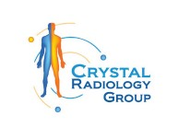What Does a Cardiac CT Scan Detect at Crystal Radiology in Auburn? (02) 8315 8292

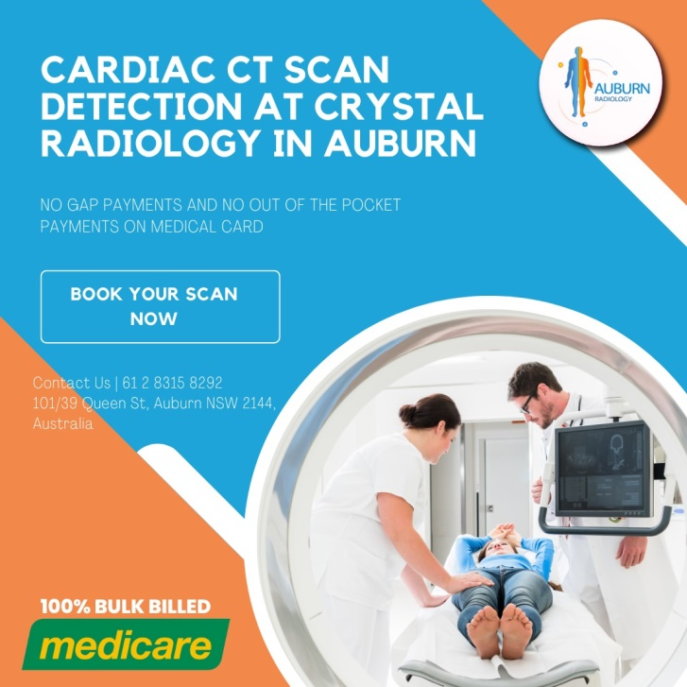A Cardiac CT Scan, a non-invasive technique that uses X-rays to visualize the heart and its associated structures, has become an integral part of diagnosing and managing heart diseases. This technology allows doctors to examine the heart in remarkable detail, making it easier to detect potential problems and devise appropriate treatment strategies.

**The Power of Cardiac CT Scans: What Can They Detect?**

[**Cardiac CT scans**](https://crystalradiology.com.au/ct-cardiac/) are powerful diagnostic tools capable of detecting a variety of heart conditions and issues. These include:

**Coronary Artery Disease**

Coronary artery disease (CAD), a condition characterized by a buildup of plaque in the arteries that supply blood to the heart, is one of the primary conditions that a cardiac CT scan can detect. The scan can spot narrowed or blocked coronary arteries and quantify the amount of calcium-containing plaque in these [**arteries**](https://crystalradiology.com.au/ct-cardiac/), a test known as coronary calcium scoring.

**Cardiac Tumors**

Although rare, tumors can grow in the heart just like they can in other parts of the body. A cardiac CT scan can reveal the presence of tumors, aiding in their diagnosis and treatment planning.

**Heart Defects**

A cardiac CT scan can help identify [**congenital heart**](https://crystalradiology.com.au/ct-cardiac/) defects, conditions that are present at birth, such as a hole in the heart, misplaced or malfunctioning valves, or abnormalities in the heart chambers.

**Pericardial Disease**

The pericardium is a thin sac that surrounds and protects the heart. Diseases of the pericardium, including pericardial effusion (fluid accumulation) and pericarditis (inflammation), can be detected with a cardiac CT scan.

**Aortic Conditions**

The aorta, the main artery that carries oxygen-rich blood from the heart to the rest of the body, can be affected by several conditions, including aortic aneurysm (a bulging or enlargement) and aortic dissection (a tear in the aorta's inner layer). A [cardiac CT](https://crystalradiology.com.au/ct-cardiac/) scan can provide detailed images of the aorta to detect these conditions.

**The Cardiac CT Scan Procedure: What to Expect**

The cardiac CT scan is a non-invasive procedure that is typically performed in a hospital's radiology department or a private imaging center. Before the scan, you may be asked to avoid caffeine and smoking, as these can interfere with the results. You might also be given a contrast dye, either orally or through an IV line, to improve the clarity of the images.

During the procedure, you'll lie down on a table attached to the CT scanner, a large doughnut-shaped machine. The table slides into the opening of the scanner, and the [**X-ray**](https://crystalradiology.com.au/ct-cardiac/) unit inside the scanner will rotate around your body to capture images from various angles. You may be asked to hold your breath for short periods to prevent blurring of the images.

The procedure itself usually takes about 15 minutes, but the preparation and post-scan procedures can make the total appointment last about an hour. The scan is painless, but some people might feel a warm sensation from the contrast dye or experience discomfort from lying still on the scanner table.

After the scan, you can typically resume your normal activities immediately. If a contrast dye was used, you'll be advised to drink plenty of water to help flush it out of your system.

**Understanding the Results**

Once your scan is complete, a radiologist—a doctor specialized in interpreting medical images—will review the CT images. The radiologist will then send a report to your doctor, who will discuss the findings with you. The results of your [**cardiac CT scan**](https://crystalradiology.com.au/ct-cardiac/) could help diagnose a heart condition, determine the severity of a known heart disease, guide treatment strategies, or even rule out cardiac conditions if your symptoms are due to other causes.

**Why Choose Crystal Radiology?**

At Crystal Radiology, we are a local and family-owned medical clinic that offers the highest quality medical and imaging services in the region. We are the leaders in bulk billing, providing the real benefit of no 'out-of-pocket' expenses for you.

[**Your Next Step**](https://crystalradiology.com.au/appointment/)

Ensure you have your Medicare card and referral with you, and visit our location for your consultation. If you have any questions, please feel free to contact us at [**(02) 8315 8292**](https://crystalradiology.com.au/appointment/) as we are here to help.

**Conclusion**

A cardiac CT scan is a powerful diagnostic tool that can detect a broad range of heart conditions, helping doctors devise appropriate treatment plans. As with any medical procedure, it's crucial to discuss any concerns with your doctor, who can provide guidance based on your individual health situation and needs. For comprehensive cardiac care, consider the CT-Cardiac Scan service at [**Crystal Radiology in Auburn**](https://crystalradiology.com.au/appointment/).